

Watering Program Manual

Ver 1.1

4th February, 2000

1. Computer Requirements 3
2. Installing SQLBase 3
3. Starting the Watering Program 3
3.1 Watering Program Main Screen 3
3.2 Pressure Adjustment Dialogue Screen 5
4. Programs Table 5
5. Program Stations Table 8
5.1 Sequencing Example 9
5.2 Manually Starting a Station or Stations: 11
5.3 Selecting Stations (Area/s) to be Watered: 11
5.3.1 1) Adding a Program Description: 11
5.3.2 2) Selecting the stations: 12
5.3.3 3) Selecting the Channel: 12
5.4 Setting up a new Station: 12
5.5 Changing a Station’s values: 12
6. Pressure Details Table 14
7. Channels Table 15
8. Pumps Table 16
8.1 Adding a new pump: 17
9. Program Switches Table 18
9.1 Displaying Program Switches: 18
10. Switches Table 19
10.1 Adding A Switch To The Watering System: 19
10.2 Assigning A Switch To A Program: 20
11. Backing-up the Watering Program database 20
11.1 Starting the backup program from the hard-disc: 20
11.2 Starting the backup program from the floppy-disc: 21
12. Restoring the Watering Program database 21
12.1 Starting the restore program from the hard-disc: 21
12.2 Starting the restore program from the floppy-disc: 22
13. Troubleshooting 22
14. General Information 23
14.1 Repopulating a Table: 23
14.2 Restarting the Watering Program: 23
14.3 Closing the Watering Program: 24
14.4 Closing and Restarting Windows: 24
14.5 Logging on to the Operating System: 24
14.6 Watering without the *%#@^#* computer: 24
14.7 Registry Settings (Advanced Users only!): 25
14.8 Warning Light: 25
15. Watering Shed Wiring Diagram 25
16. Watering Pumps Switching Diagram 25

The Watering System consists of a computer in the Watering Shed which switches sprinklers on and off at different times and in different places. These times can be easily changed to suit the prevailing conditions. (It may be considered somewhat inappropriate to irrigate during a rainstorm!)

The computer controls switches (solenoids) which are set into the ground at various places up and down the rows of pots. The switches turn the water on and off to a particular row or set of rows. These selected areas are called Stations.

Computer Requirements
The watering program requires a computer with a Pentium or better processor, which is running Windows 95/ 98 or better, preferably running Windows NT workstation or Windows 2000, with a minimum of 1 serial port. It must have Centura SQLBase 1user version or 25 user if desperate.

Installing SQLBase
- Connect computer to network.
- Go to k:\SQLBase 7.5.1 CD Key 8842 (Or later version if on network)
- In the directory \SQLBase Server run the program ‘setup.exe’
- Install SQLBase, following the prompts.
- Install a copy of the watering.dbs file and any *.log files in the ‘from’ directory into c:\centura\watering directory. This file can be found on backup floppy or on Graham’s computer in c:\centura\watering.
- Place a copy of ‘water9.exe’ into a c:\centura\waterexe directory.
- Put a shortcut to c:\centura\waterexe\water9.exe into the startup folder in the ‘Start’ menu.

Starting the Watering Program

- Click the START button
- Choose Programs
- Choose water7 (Wait while the program starts)
- Click the Start Icon on the top of the Main Screen (the Traffic Light)

Watering Program Main Screen
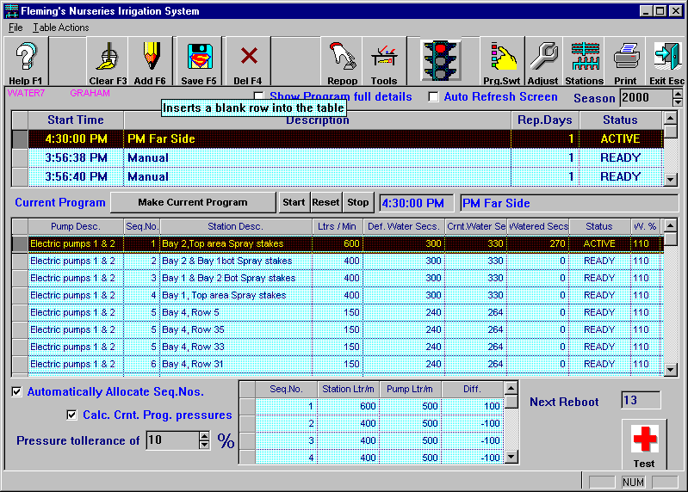

There are three main sections on the main screen. The top section (three rows) called Programs Table, the middle section called Program Stations Table and the bottom section (four rows) called Pressure Details Table.

Toolbar Buttons – All the options presented on the toolbar are available from the dropdown menus at the top of the screen.

Help – There is no online help available with the Watering Program.

Clear F3 – Unselects the selected row/s which have not yet been saved.

Add F6 – Begins the editing of a new row.

Save F5 – Writes the current values to the hard disc.

Del F4 – (Delete) Marks the selected row/s for deletion. Deletion only occurs when the table is saved. (Undelete is found by clicking the Tools button – see below)

Repop – (Repopulate) Reloads the selected table with the latest data available from the hard disc.

Tools – Opens a new screen with many of the same options already available on the toolbar and some others. Again, all these options are also available from the dropdown menus.

[Traffic Light] – (Image only) This is the main START/STOP button for the Watering Program.

Prg. Swt – (Program Switches) Allows the operator to add other devices to the Watering System and allocate them appropriate addresses and channels.

Adjust – (see W% below)

Pressure Adjustment Dialogue Screen

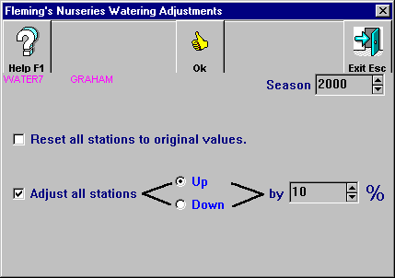
Stations – Clicking this button brings up the Program Stations Table. Here, the operator can select an area or areas to be watered or define a new area (Station)

Print – Prints

Exit Esc – Exits the current table or Program

Programs Table

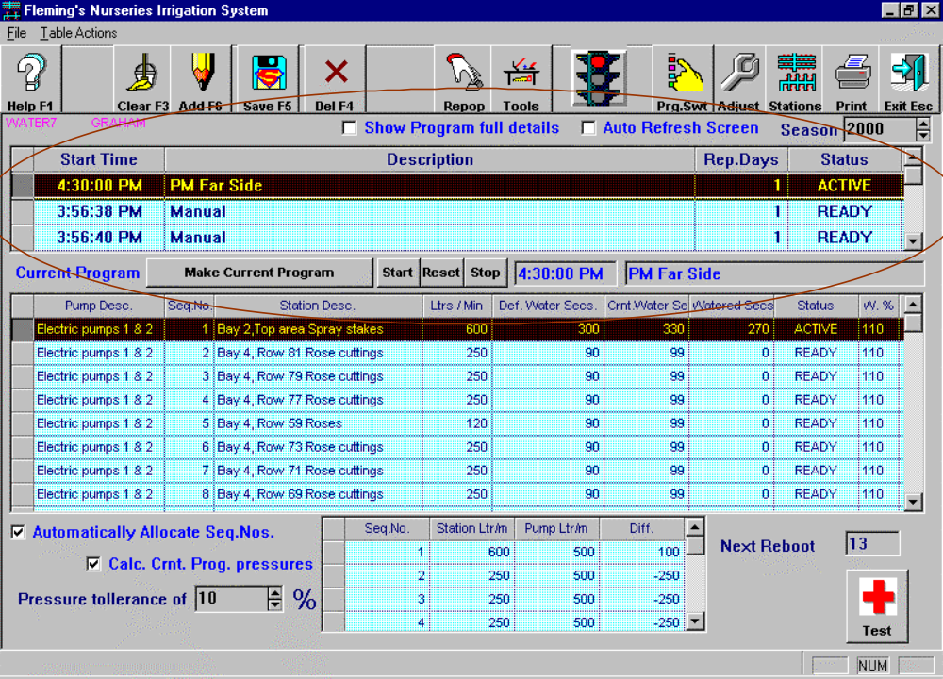

Checkboxes:

Auto Refresh Screen - This option is off by default but if you tick it then you will see the screen update every ten seconds.

Show Program Full Details - By default this is not checked. Click this box and you will see two more fields appear in the Programs table. These extra fields [Start DT] and [Due Next DT] and are described below.

The Programs Table fields and their descriptions follow:

Start Time - The time the program will start (e.g. 10:36:10 AM)

[Start DT] – (Start Date Time) The date and time that this program will start
(e.g. 05-Oct-1999 10:36:10 AM)

[Due Next DT] – (Due Next Date Time) (See also Rep.Days below) The next date and time that this program will start after the Start DT . This date is determined by adding the Rep. Days (Repeat Days) to the Start DT. (e.g. If the Rep. Days value is three and the Start DT value is 05-Oct-1999 then the Due Next DT will be 08-Oct-1999)

Description – Tells you what the program is actually doing!

Rep.Days – (Repeat days) (See also Due Next DT above) the program will run again every e.g. 1, 2 or 3 days etc) If the Rep. Days value is 2 then the program will run every second day.

Status – Clicking on this field will reveal three dropdown menu items:

ACTIVE – the Program is running

READY – the program is not running but will start at the next Start Time or immediately if it hasn’t yet run. (See also Due Next DT)

STOPPED - the program is not running but will run the next day (or whenever it is supposed to run next)

[Therefore, it appears that there is no difference between READY and STOPPED – this needs to be clarified with the programmers.]

NB: The only way to prevent a program in the queue from starting is to delete it. STOPPED only means that it will start again the next due date/time.

Defunct Options On Main Screen– no longer available:
"Next Reboot [1]"
"Test"

Command Pushbuttons:
"Make Current Program"

This button is only used when the operator creates a new Station (a selection of areas to be watered – see also Setting Up A New Station) Clicking this button updates the Program Stations Table to show the new Station details – blank at the beginning of the Station creation process. Normally, just selecting a new program in the Program Table will automatically update the program Station Table details also.

The individual programs are normally queued in the order in which they will run according to their Start Time. The order from top to bottom is ACTIVE, READY STOPPED. This order can be overridden by using the three buttons below.

Note: The following three pushbuttons require the Watering program to be stopped for them to have any effect. An error message is generated if the operator attempts to use them while the Program is running.

"Start"

Sets the selected individual program to run immediately upon restarting the Watering program. Places the program at the beginning of the queue irrespective of its Start Time.

"Reset"

Returns the selected individual program to its READY status so that it will run at the Next Due DT when the Watering program starts. Moves the individual program back into its normal place in the queue.

"Stop"

Prevents the individual program from running even if the Watering Program has started. Places the program at the end of the queue.

Program Stations Table

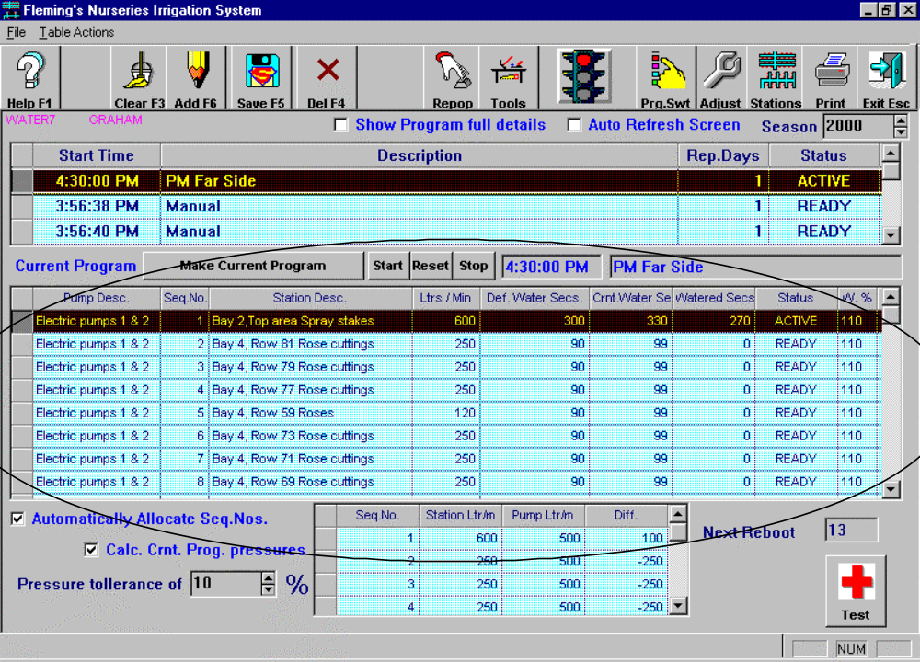

The Programs Stations Table fields and their descriptions follow:

Pump Desc. - (Pump Description) Which pumps are being used to do the watering. At present there are only two pumps working together called “Electric Pumps 1 & 2”
Seq.No. - (Sequence Number) The pump output capacity is set at 500 Ltrs/Min (litres per minute) Each area selected for watering has a Ltrs/Min value assigned to it by the operator, e.g. BAY 4 Row 17 = 150 Ltrs/Min.

What happens when, for example, 4 areas are selected for one program each of which has a Ltrs/Min value of 150? The program is asking for 600 Ltrs/Min (4 * 150) but the pump can only supply 500! This is where “Sequencing” steps in.

Note the checkbox at the bottom left-hand side of the screen called “Automatically Allocate Seq.Nos.” By default this box is ticked and therefore active. We select 4 rows to be watered Rows 11, 13, 15 and 17 (see below Selecting Stations (Area/s) to be Watered) The Watering Program calculates the Seq.Nos. in this way:

Sequencing Example

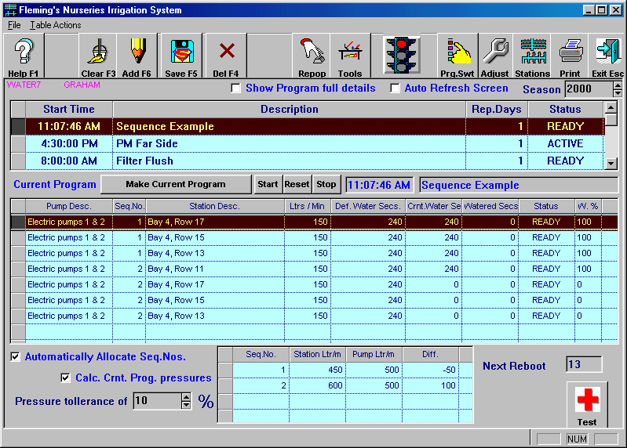

Note that the first three rows (of the 4 we selected) are assigned to Seq 1). That is, the program realizes that 3 * 150 = 450 which is less than 500 so the pump can cope with it but 4 * 150 = 600 which is more than the pump can deliver. Therefore, theoretically, the program should water the first three rows (Seq 1) for the allocated number of seconds (minutes), switch off these three rows and then begin to water the remaining row (requiring 150 Ltrs/Min). However, there is a slight problem. The pump is still delivering 500 Ltrs/Min so where does the other 350 (500 – 150) go?

This is where Seq 2) comes to the rescue. The system must pump out the remaining 350 litres somewhere so it has been set up to select from the already watered rows and send the “excess” water to them at the same time as water the remaining row. If the remaining row needs 240 seconds of water then two other rows will be watered also for another 240 seconds. If, however, the fourth (unwatered) row only required 120 seconds of water then the other two “rewatered” rows would only be watered again for the 120 seconds (i.e. the time value required by the remaining unwatered row). When that fourth row has been watered for its 120 seconds then ALL the rows switch off and that program is complete.
(During this “overwatering” the Crnt.Water Secs. value reads “0” for the rows which were previously watered.)

You might ask what would happen if one area to be watered was set up as requiring 600 Ltrs/Min? That would be a good question. The answer is – “Nothing”. The pump cannot deliver more than it can deliver so any value over 500 is ignored.

You might also ask what would happen if you just had one or two stations requiring well below the pump’s rated output capacity and no other stations. Well, the pressure would be so great that you would probably blow the fittings off the end of the sprinklers so don’t try it! Sequencing only comes into effect when the combined output of the stations selected is greater than the output capacity of the pump.

The “Automatically Allocate Seq.Nos.” checkbox can be “unchecked” and the sequencing can be done manually if you so desire.

It would be possible to have a system which watered each row with exactly the right amount of water but that would be far more expensive and complicated. Clear as mud? Well that’s what happens when you have all that water laying around.

Station Desc. – (Station Description) What area is being watered. A “Station” is a collection of one or more Rows in one or more Bays.

Ltrs/Min – (Litres per Minute) How much water is allocated to each area.

Def. Water Secs – (Default Water Seconds) The default length of time in seconds that the area will be watered for.

Crnt.Water Secs - (Current Water Seconds) The actual length of time the area will be watered for in seconds. This value can be altered but is usually the same value as the default value – see “Default Water Seconds” above.

Watered Secs. – (Watered Seconds) The actual length of time in seconds that the area has been watered for so far. This value changes during the program cycle every ten seconds but the screen is not updated until the end of the sequence. Note the checkbox at the top right of the main screen called “Auto Refresh Screen”. This is off by default but if you click it then you will see the screen update every ten seconds.

Status – (See “Status” above) Whether the program is Ready, Active or Stopped. This field can be changed by the operator.

W% - The percentage by which the volume of water to all stations is either increased or decreased: e.g. During a dry spell you might increase the volume of water by 20%. This value is set by clicking the [Adjust] button on the main toolbar. A value of “Up by 10%” means that all stations will receive 10% more than the currently allocated water volume.

There are three more options available on the toolbar in this screen…

Mn.Strt – (Manual Start) Selecting any number of rows and clicking this button will send these area directly to the front of the queue and they will start as soon as the Watering Program starts. (See Manually Starting a Station or Stations)

Channel – Each area (or individual program) to be watered must be allocated a physical channel. Clicking this button brings up the Channels Table:

Pumps - In the Stations table you will also see a button marked “Pumps”. Clicking this button will bring up the Pumps table over the top of the main screen and Station screen.

Manually Starting a Station or Stations:

- Stop the Watering Program (If there is a program in the ACTIVE or READY state then press STOP. If a program has not run yet but “should have” due to it’s Start Time then that program will start next even if you start a program manually (below). TO START THE MANUAL PROGRAM IMMEDIATELY you need to STOP all READY or ACTIVE programs before setting up the new Manual Start program otherwise when you start the System the first program to run will be the program that hasn’t run yet but should have. When this program - and all others in the READY status which should have run - completes then the Manual Start program will run.)
- Click Stations to open the table
- Select a row or rows
- Click Mn.Strt (Manual Start)
- Exit the Programs Stations table.
- Repopulate the Programs table by clicking Repop. (Sequence numbers are not automatically generated by the Watering Program in a Manual Start and cannot be entered manually either. Any areas you select will all be watered simultaneously. For more information about Sequencing see Allocating Sequence Numbers)
- Start the Watering Program with the Traffic Light Switch. (The area/s you selected will begin to be watered immediately but you will only be able to see this if the Auto Refresh Screen checkbox is ticked.)

Selecting Stations (Area/s) to be Watered:
There are three main tasks:
- Adding a program description
- Selecting the stations
- Selecting the channel

1) Adding a Program Description:

- Stop the Watering Program.
- Click Add F6 (A dialog box will ask you to Select the table on which you wish this action to be performed (Choose the Programs table)
- Click the “Make Current Program” button which will reset the Programs Stations table with blank rows
- Click in the Description field of the Programs table and type in a short description of the area/s you want to water
- Click in the Start Time field and type in the time you want the program to start (the current time is entered automatically but can be changed if you wish)
- Click in the Rep. Days field and type in how often you want the program to run.
- Click in the Status field and choose the appropriate value from the dropdown arrow tool. (By default the value is “READY” which means that it will run at the next appropriate time according to the values you entered in the Start Time and Next Due Date fields. You can choose STOPPED and ACTIVE also.)
- Save the table

2) Selecting the stations:

- Click Stations
- Highlight the row/s you want to be watered. If you want to enter a new area see Setting up a New Station: (To select multiple rows use normal Windows procedures)

3) Selecting the Channel:

- Click Channel
- Highlight the row of an appropriate (usually unallocated) Channel
- Click Select (you will be returned to the Stations table)
- Click Select (you will be returned to the main screen)
- Save the table (If the Automatically Allocate Seq. Nos. checkbox is ticked the Program will allocate the sequence numbers otherwise it will have to be done manually. See also Automatically Allocate Seq. Nos.)
- Click on the main Program Start button (the traffic lights) and the newly created program will be placed in the queue at the appropriate place.

Setting up a new Station:

- Click Stations on the main screen.
- Click Add F6
- Click Channel
- Scroll down the list to choose the Channel number you want to allocate to the new Station. (Normally you would choose a currently unallocated channel but if there are none left you might have to choose one that has already been allocated to another area)
- Highlight the row you have chosen as the channel.
- Click Select and the Channels table disappears and you are returned to the Stations table.
- Click Pumps to choose which pumps you want for this Station
- Highlight the row containing the pump/s you want to use
- Click Select and the Pumps table disappears and you are returned to the Stations table.
- Click in the Station Desc. (Station Descriptions) field and type in a description of the new Station.
- Click in the Ltr / Min field and type in how much water you want to water this Station with.
- Click in the Def. Water Secs and type in the usual amount of time to water this station for.
- Save the table.

Changing a Station’s values:

- Stop the Watering Program
- Highlight the particular program you wish to change in the Program Table
- Click on the value you wish to change in the Programs Stations Table and type in the new value (You can change the Seq.No., the Crnt.WaterSecs and the Watered Secs values)
- Save the table
- Restart the Watering Program

Pressure Details Table
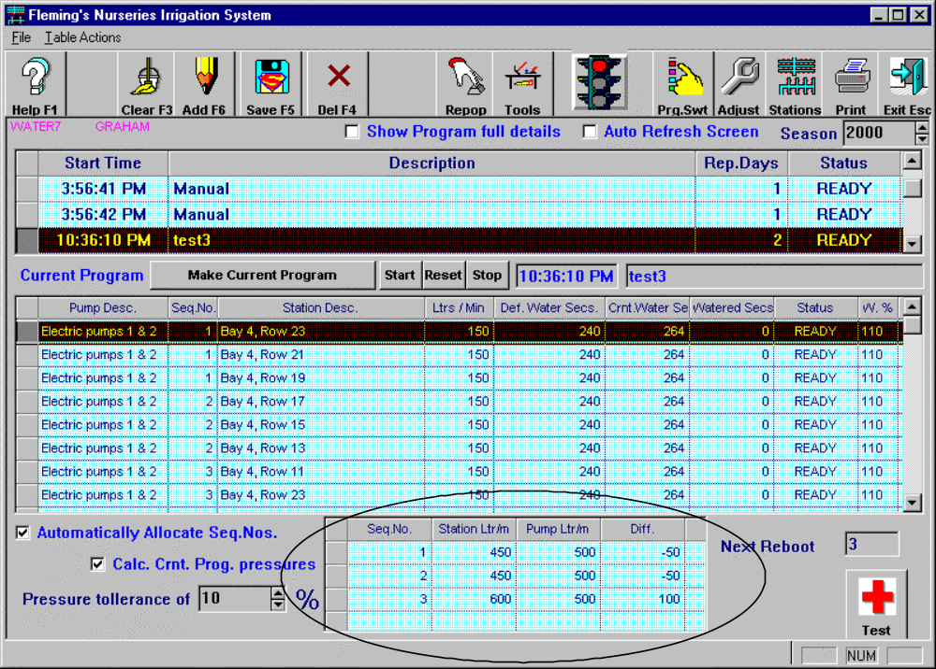
This table shows how much pressure difference (Ltrs/Min) there is between the sum of the pressures required by individual Rows allocated to a Sequence no. and the output volume of the pump.

The main screen shows that Seq 1) has a total combined pressure of 450 Ltr/Min. Since the pump’s output is 500 Ltrs/Min then there is a net difference of –50 Ltrs/Min. Seq 2) also has a total of 450 Ltrs/Min which is 50 Ltrs/Min under the pump’s output capacity. The final sequence (3) has a total value of 600 Ltrs/Min (the other two rows are not visible on the screen). However, the program does not create another sequence – WHY IS THIS SO?

The Pressure Details Table fields and their descriptions follow:

Seq.No. - (Sequence Number) – See “Seq No.” above.

Station Ltr/m - (Station Litres Per Minute) – The sum of the pressures required by the individual Rows of a Sequence.

Pump Ltr/m – (Pump Litres Per Minute) The current output capacity of the selected pump/s.
Diff. - (Difference) – the difference between the Station Ltr/m and the Pump Ltr/m.

At the bottom left of the screen you will see a checkbox called "Calc. Crnt. Prog. pressures". By default this checkbox is ticked and the program pressures of the currently selected program are calculated automatically. It can also be unselected.

Note also the spinbox at the bottom left of the screen - "Pressure tollerance of [x] %". This field allows the operator to directly enter a value or use the up and down arrows. When the Program calculates the Seq.No. as described above it will look to the value in this field to determine how many sequences it will create. For example, if the pressure tollerance is 50% then the Program will create more sequences than if it is 10%.

To recalculate the pressure tollerances the operator will have to first select a new value in the area provided then edit any of the rows in the Program Stations Table then save it. This forces the recalculation. The easiest way to accomplish this is to click on the status field in one of the rows and reselect the current value which leaves the field exactly as it was. Then save the table. The program thinks that something has changed and recalculates the pressures.

Channels Table

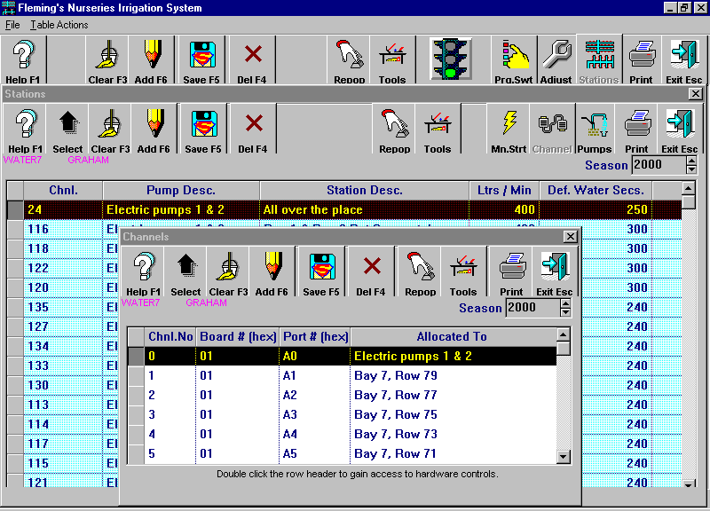
The Channels Table fields and their descriptions follow:

Chnl.No – (Channel Number) A Channel consists of a Board # and a Port # and is allocated to a particular switch (solenoid) in a particular area (e.g. Bay 4 Row 17) It represents the physical wiring address as set up on the wiring boards in the Watering Shed (see Watering Wiring Diagram) Each Channel is numbered in the range from 0 to 47 and from 100 to 147 giving a total number of 96 possible channels.

Board # (hex) – Which of the four main wiring boards is currently selected.

Port # (hex) – Which of the 24 volt signal senders is currently selected (Each board has three hex groups A0-A7, B0-B7 and C0-C7).

Allocated To – The description of the area connected to this Board/Port combination.

Pumps Table

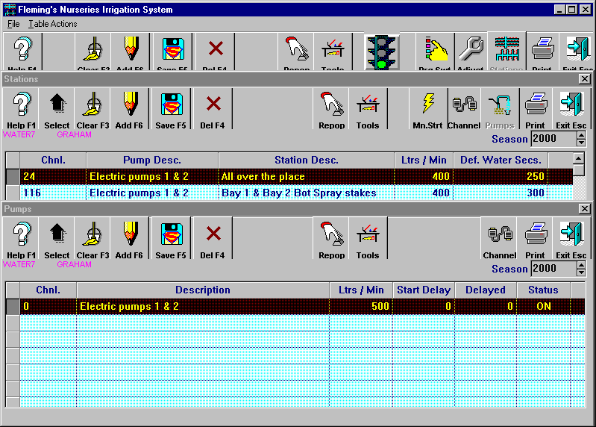

The Pumps Table fields and their descriptions follow:
(See also Adding a new Pump)

Chnl. – (Channel) The Pumps Table (above) shows the pumps currently used. Electric Pumps 1 & 2 have been assigned to channel (0)

Description – Type of pump/s.

Ltrs / Min (Litres per Minute) – The output capacity of the pump/s.

Start Delay – This field allows the operator to specify how long after the pump shuts down the pump will switch back on again. For example, if a station is set up which only requires 150 Ltrs/Min and the pump output is 500 Ltrs/Min the flow-gauge will register that there are not enough outlets for the pump to work at its rated output and the pump will switch off. The pump will switch on again but the Start Delay will allow the pump either to cool or “settle down” before it restarts. If this field isn’t used a situation might occur where the pump was switching off and immediately back on again very quickly for hours at a time. In fact, a number of pump motors have been burnt out because of this.

Delayed – If the Pump Start is delayed by a value set in the Start Delay field then the program will show how much of this Delay time has elapsed. This figure is updated regularly until the pump restarts.

Status – Shows whether the pump is currently On or Off.

Adding a new pump:

- Click Stations on the main screen.
- Click Pumps on the Stations screen.
- Click Add F6
- Click Channel
- Scroll down the list to choose the Channel number you want to allocate to the new pump/s. Normally you would choose a currently unallocated channel but if there are none left you might have to choose one that has already been allocated to another area. (This might mean that you have to spend more money to upgrade the system!)
- Click Select - the Channels table disappears and you are returned to the Pumps table.
- Click in the Description field and type in a Description of the new pump/s.
- Click in the Ltr / Min field Type in the output capacity of the new pump/s.
- Click in the Start Delay field and type in the Start Delay time.
- Click in the Delayed field and type in the amount of time by which the pump's start is delayed.
- Click in the Status field and choose the Status value (On/Off)
- Save the table (If you open the Channels table again you will see that the channel you chose for the new pump/s now has the Description you entered in the Pumps table in the “Allocated To” field)
- Save the table

Program Switches Table
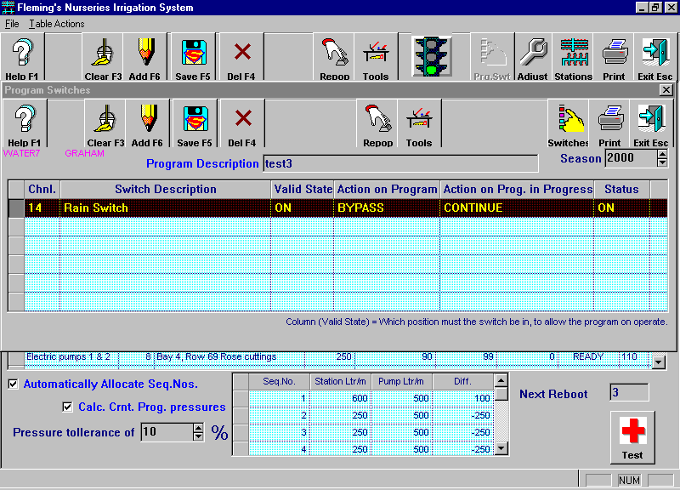
Any program in the queue can have extra devices (switches) associated with it. For example, a Rain Switch or a Frost Switch. The rain switch would be set up to prevent an area being watered if a certain amount of rain has fallen. A Frost Switch would be set up to water particular frost-sensitive areas if the temperature fell beneath a certain predefined value.

Displaying Program Switches:

- Highlight the program in the queue for which you want to display the switches
- Click on the Prg.Swt button on the main screen. (This table shows the extra devices attached to the highlighted queue program.)

The Programs Switches Table fields and their descriptions follow:

Chnl – (Channel) The channel to which the device has been allocated.
Switch Description – What sort of device is this?
Valid State – Which position must the switch be in to allow the program to operate? E.g. The Rain Switch must be ON to permit the area to be watered. The Frost Switch must be OFF to let the area be watered.

Action on Program – What do you want the program to do when the switch kicks in. You might set the Rain Switch to ACTIVATE which would shut off the watering system for that area. However, you might decide that you will water the area anyway so you can set this option to BYPASS.

Action on Prog. In Progress – (Action on Program In Progress) Originally this was to be set up as another option asking what should happen if the switch kicked in while the program was already running.. This option was not programmatically pursued so the value of the option is permanently set to CONTINUE and cannot be altered.

Status – Is the switch currently ON or OFF

Switches Table
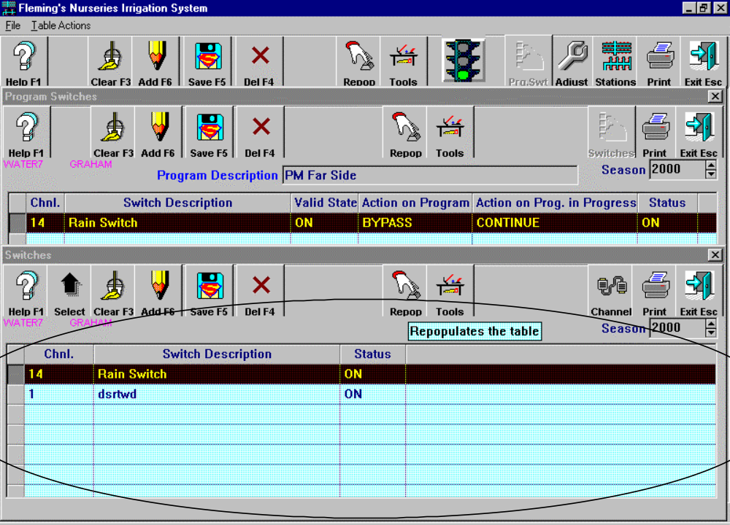

Devices (Switches) can be added and removed in the Switches table accessed by clicking the Switches button in the Program Switches table screen.
The Switches Table fields and their descriptions follow:

Chnl – (Channel) The channel to which the device has been allocated.

Switch Description – What sort of device is this?

Status – Is the switch currently ON or OFF

Adding A Switch To The Watering System:
(See also - Assigning A Switch To A Program)

- Click the Prg.Swt button on the main screen.
- Click Switches in the Program Switches table.
- Click ADD F6 in the Switches table.
- Highlight the newly created blank row.
- Click Channel and scroll down the list to choose the Channel number you want to allocate to the new Switch. (Normally you would choose a currently unallocated channel but if there are none left you might have to choose one that has already been allocated)
- Click Select - the Channels table disappears and you are returned to the Switches table.
- Click in the Descriptions field and add a description of the switch.
- Click in the Status field and use the down arrow to select either ON or OFF.
- Save the table (When you Exit the table you will be asked if you want to repopulate the table. Answer yes repopulate the entire table)

Assigning A Switch To A Program:

- Highlight the program in the queue (on the main screen) to which you want to add a switch.
- Click on the Prg.Swt button on the main screen.
- Click ADD F6.
- Click Switches.
- Highlight the row which contains the Switch you want to add to the program.
- Click Select - the Switches table disappears and you are returned to the Program Switches table.
- Choose various option s in the Valid State, Action On Program and Status fields.
- Save the Program Switches table.
- Exit the Program Switches table (The Switch you selected is now allocated to the program you selected)

Backing-up the Watering Program database

The Watering Program database is called water7.dbs. It is a good idea to back the database up if you have entered new programs. Otherwise, if the system crashes then you will have to manually enter all those programs again!

The backup program is called “w_backup.bat” and can be found in the directory on the watering computer C:\Centura\water7\Watering backup or on a floppy disk available from your friendly programmers! It uses another program called Winzip to compress the database so that it will fit on a 1.44MB floppy disk. The backup database file is called waterbak.zip.

Starting the backup program from the hard-disc:

- STOP the watering program
- Place a floppy disc in the A Drive
- Click on START
- Choose PROGRAMS
- Choose WINDOWS EXPLORER
- Double-click the Centura directory
- Double-click the water7 directory
- Double-click the Watering Backup directory
- Double-click “w_backup.bat” (If the backup database file “waterbak.zip” is already on the floppy disc the program will ask if you want to overwrite it. If you do then answer “Yes” otherwise answer “No” and then program will terminate without overwriting it).

Starting the backup program from the floppy-disc:

- STOP the watering program
- Place the floppy disc containing the backup program in the A Drive
- Click on START
- Choose PROGRAMS
- Choose WINDOWS EXPLORER
- Double-click 3 1/2 Floppy (A:)
- Double-click “w_backup.bat” (If the backup database file “waterbak.zip” is already on the floppy disc the program will ask if you want to overwrite it. If you do then answer “Yes” otherwise answer “No” and then program will terminate without overwriting it).

Restoring the Watering Program database

The Watering Program database is called water7.dbs. The backed-up database file is called waterbak.zip. The restore program is called “w_restore.bat” and can be found in the directory on the watering computer “C:\Centura\water7\Watering backup” or on a floppy disk available from your friendly programmers! It uses another program called Winzip to decompress the database and copy it back to the Watering Program. The restore program does not overwrite the old database file already on the hard disc but renames it to “water7.old”.

Starting the restore program from the hard-disc:

- STOP the watering program
- Place the floppy disc containing the already backed-up watering database called waterbak.zip in the A Drive
- Click on START
- Choose PROGRAMS
- Choose WINDOWS EXPLORER
- Double-click the Centura directory
- Double-click the water7 directory
- Double-click the Watering Backup directory
- Double-click the program file “w_restore.bat” (The database file “waterbak.zip” should be on the floppy disc in the A Drive)

Starting the restore program from the floppy-disc:

- STOP the watering program
- Place the floppy disc containing the backup program in the A Drive
- Click on START
- Choose PROGRAMS
- Choose WINDOWS EXPLORER
- Double-click 3 ¹/₂ Floppy (A:)
- Double-click “w_restore.bat” (The database file “waterbak.zip” should be on the floppy disc in the A Drive)

Troubleshooting

Problem | Probable Cause | Fix
Program appears to be running on computer, but pump not running and solenoids not open. | 24v power not available to system. | Is the warning light flashing, if so:  It will be a problem with the transormer.  Check fuse on top of the 24 volt transformer.  Check power output of 24v transformer  If no power replace fuse anyway.  If still no power, replace transformer.  If transformer OK, check for power between looped terminals  If no power check connections.  Give up and water by hand.  If not flashing:  Check that the rain switch is not activated.
Only 1 station not operating. | Either the solenoid is not operating or the black output module is not operating. | Use manual activation to activate the solenoid.  Check for power at solenoid  Remove the electrical solenoid to clear 2 bleed holes underneath.  Whilst out, check that the plunger is retracted into the body.  If not in:  Check that you have activated the correct solenoid via the computer.  If on:  Use multimeter to check for power going into the solenoid.  If power, replace electrical part of solenoid.  If not power:  Check for power output from terminal on board by seeing if light is on.  If light is on:  Check power output from module by testing with mulimeter connecting to ‘Common’ wire, (a mass of wires going into a joiner under boxes) and to the output side of the module (The screw terminal where the wire disappears behind the panel, not the looped wire). (While there compare the power on the input terminal {looped wire} to the output terminal)  If no power replace module.  If no power, and module is OK, check wiring.
Thirsty | Haven’t drunk beer for five minutes | Drink beer  If still thirsty drink more beer
No water (or little water) coming from pump | Stuffed pump | Fix it!
 | Blocked Filters | Unblock filters
 | Solenoids on the delivery side of sand filters not operating correctly | Check flush cycle for even and reasonable flow from each outlet pipe.  If good flow, this is not problem.  Else check for power at solenoid.  Else replace solenoid diaphram (this happened in summer 2000/01)  If problem with the solenoids the sand in filters will have solidified. Open and stir until loose, being careful of inlet pipes at bottom of sand.

General Information

Repopulating a Table:

Sometimes it is necessary to manually repopulate a table. This means that the watering database is re-queried by the watering program and the most up-to-date information is presented on the screen. You may need to do this when manually starting a program or at other times.

When you repopulate a table you will be asked which table you want to repopulate. There are two choices – the Programs Table or the Program Stations Table. Choose the appropriate table and click OK.

You will then be asked “Do you want to only repopulate the selected rows?” If you answer “Yes” then ONLY the rows which are highlighted on the screen will be refreshed. If you answer “No” then the WHOLE table will be refreshed. If in doubt just answer “No” which will result in a completely up-to-date table.

Restarting the Watering Program:

Occasionally it may be necessary to restart (reboot) the program if it gets confused or comes up with strange messages or it runs out of memory etc. It’s best if you try to exit the system gracefully (as they say in computerland). That means you try to close the program and then close Windows before starting it up again. This isn’t always possible so you might have to simply push the power off/on switch.

If an error occurs and the system is “stuck” or doesn’t seem to be working properly…

Closing the Watering Program:

Try to close the program the normal way through the dropdown File Menu (Exit) or by clicking on the X at the top right-hand side of the screen. (You may have to answer the error message window first but don’t worry too much about that. Click OK or YES and then try to close the program.)

If that isn’t possible and nothing happens then press the reset button on the computer. If THAT doesn’t work then switch the %^$@*%^$ thing off and switch it back on again!

Closing and Restarting Windows:

If you can close the Watering Program normally then you should close Windows as well in the normal way -

Click the START button at the bottom left-hand side of the screen.
Choose SHUT DOWN
Choose RESTART
Choose OK.

Remember, if that doesn’t work or you wait for a few minutes and nothing seems to be happening then press the reset button on the computer. If THAT doesn’t work then switch the %^$@*%^$ thing off and switch it back on again!

It might ask you to select from a list of reboot options when it restarts. This just means that it recognizes that it didn’t switch off properly before and wants to reset itself. Accept the default option it gives you of Number 3) “Open in Safe Mode” by pressing ENTER, then when it opens up click OK to the message telling you it has opened in Safe Mode, then Restart Windows (See “Closing Windows” – above).

Logging on to the Operating System:

A logon screen will appear with the username of “graham”. There is no password (it is blank) so just press ENTER or Click OK and in about a minute or so the Watering Program will Start automatically.

Choose Auto Refresh on the Main Screen when it comes up and you will see the first station in the queue turn to ACTIVE if it is due to run. Any programs that haven’t run (because the system may have been down for a while) will now run until it “catches up” to where it should be. Pretty clever program eh!

Watering without the *%#@^#* computer:

Believe it or not it is actually possible to water the plants without a computer. Farmers have managed to do it for thousands of years and so can you. Here’s how…

- Open about four solenoids in the paddock by hand. (If you turn the pump switch to manual before the solenoids the pump won’t operate because it has an automatic cutout if there is no water flow)
- Go back to the Watering Shed and turn the switch on Switch Box 1 to “Manual” (see Pump Diagram)
- When you want to water elsewhere open another solenoid before switching another one off.

Registry Settings (Advanced Users only!):

In Registry Address:

HKEY_LOCAL_MACHINE\SOFTWARE\FlemingsSystem\Watering\GENERAL

you will find various values used by the Watering Program. User changeable keys are:

- DaysToKeepLogs
- MinSecondsBetweenPrograms
- RebootDelay
- TimerCheckInterval
- WarningDeviceChanel

Warning Light:

There is a warning light on top of the watering shed. This light will come on when there is something wrong with the watering program. It means that someone has to do something to fix it. That’s about all the information this gives you. Find someone who cares and tell them that the light is flashing. That’s all I can tell you!

Watering Shed Wiring Diagram

Watering Pumps Switching Diagram

THE END

